Conflict-Related Sexual Violence (CRSV) & Reparation Deficits in Nigeria: An Empirical Policy Assessment (1995–2023)
Author: Sayemo Harris
Date: October 2026

1. Executive Summary
This policy report provides a systematic evaluation of institutional culpability, longitudinal severity patterns, and post-conflict reparation deficits related to Conflict-Related Sexual Violence (CRSV) in Nigeria. Grounded in standardized, longitudinal conflict actor data from 1995 to 2023, the analysis moves beyond localized case studies to construct an empirical baseline of liability across sovereign security forces and non-state insurgent factions.

Core Analytical Findings
- Aggregated Institutional Culpability (33 Cumulative Actor-Violation Years): Between 1995 and 2023, armed actors in Nigeria accumulated a combined 33 actor-years of active, documented sexual violence. Because state forces and insurgent groups operated concurrently during high-intensity conflict phases, this total reflects independent, additive institutional liability rather than non-overlapping calendar duration.
- Direct State Accountability (14 Actor-Years / 42.4%): Statutory armed forces (incorporating military formations and police commands) account for 14 documented violation actor-years between 2004 and 2019. Because statutory actors bear positive human rights and international humanitarian law obligations, this substantial share establishes an unavoidable state duty to provide administrative redress and guarantees of non-recurrence.
- Protracted Insurgent Severity (19 Actor-Years / 57.6%): Non-State Armed Groups specifically Boko Haram (Jamā'at Ahl as-Sunnah lid-Da'wah wa'l-Jihād - JAS) and the Islamic State West Africa Province (ISWAP) demonstrate sustained violations, maintaining peak systematic severity (prevalence level 3) through 2023.
- High-Risk Targeting of Children (19 Actor-Years): In 19 actor-years, violations against children reached massive or systematic proportions (prevalence score >= 2), highlighting a protracted vulnerability profile requiring specialized, multi-generational reparative frameworks.
- The Structural Reparations Deficit: Despite clear evidence of systematic harm spanning decades, victim redress remains stalled within protracted criminal justice mechanisms or subordinated to counter-insurgency agendas. There is an urgent policy deficit in dedicated, non-judicial administrative reparations and Interim Reparative Measures (IRMs).
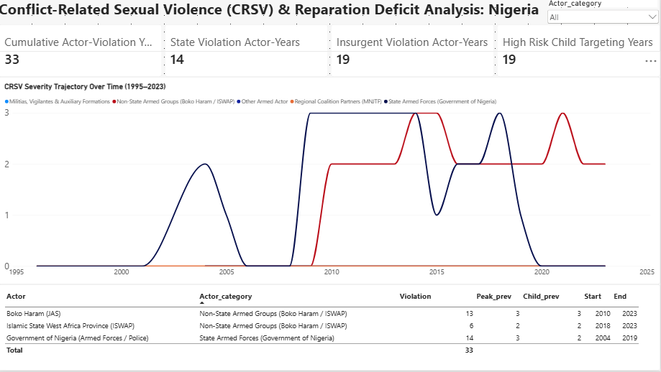

2. Methodology & Analytical Framework

2.1 Scope and Unit of Analysis
- Temporal Coverage: 1995–2023 conflict actor-years within the territorial boundaries of Nigeria.
- Analytical Actor Groupings:
  - State Armed Forces (Government of Nigeria): Statutory national military services, joint task forces, and national police operational units.
  - Non-State Armed Groups: Boko Haram (JAS) and Islamic State West Africa Province (ISWAP).
- Unit of Measurement: The primary quantitative metric is the Actor-Year. Where multiple armed actors commit documented violations in the same calendar year, each actor accumulates an autonomous actor-year of liability.
- Prevalence Scoring Framework: Severity is benchmarked against international SVAC coding standards:
  - 0 (None): No reported sexual violence.
  - 1 (Isolated): Sporadic or isolated incidents reported (under 25 estimated victims).
  - 2 (Massive / Widespread): Widespread, continuous incidents (25 to hundreds of victims).
  - 3 (Systematic / Strategic): Systematic use as a tactic of warfare, mass abductions, or institutionalized detention abuse.

2.2 Core Equations & Calculations

Cumulative Actor-Violation Years = sum(Actors) (Years with max_prevalence >= 1) = 33
State Institutional Liability = 14 actor-years (42.4%)
Insurgent Liability (JAS / ISWAP) = 19 actor-years (57.6%)
High-Risk Child Targeting = sum(Actors) (Years with child_prevalence >= 2) = 19 actor-years

3. Comparative Longitudinal Findings
Actor Name | Analytical Category | Documented Violation Years | Peak Severity (0–3) | Peak Child Prevalence (0–3) | Active Horizon
Boko Haram (JAS) | Non-State Armed Groups | 13 | 3 (Systematic) | 3 (Systematic) | 2010 – 2023
Islamic State West Africa Province (ISWAP) | Non-State Armed Groups | 6 | 2 (Massive) | 2 (Massive) | 2018 – 2023
Government of Nigeria (Armed Forces / Police) | State Armed Forces | 14 | 3 (Systematic) | 2 (Massive) | 2004 – 2019
Cross-Conflict Aggregation | Combined Profile | 33 | 3 | 3 | 1995 – 2023

Analytical Trajectory & Responsibility Deficits
- State Force Violations (2004–2019): Documentation covers early internal security operations through counter-insurgency surges around 2014–2016, with recorded incidents in formal operations, screening sites, and displacement settings. Because the state holds legal sovereignty, these 14 violation actor-years demand state-funded reparative measures that do not depend on individual criminal convictions.
- Insurgent Splinter Dynamics (Post-2015): The bifurcation of Boko Haram into JAS and ISWAP around 2016 decentralized the operational pattern of violence. JAS retained high child-targeting prevalence via abductions and forced marriages, while ISWAP institutionalized social control across rural operational theaters. In the absence of viable legal recourse against insurgent commanders, the state maintains a surrogate duty to facilitate victim redress.

4. Key Limitations & Strategic Recommendations

4.1 Addressing the Survivor-Centric Evidence Gap
While conflict actor datasets establish a definitive baseline of institutional culpability, they remain inherently perpetrator- and incident-centric. They track the frequency, timing, and severity of violations committed by armed factions, but they do not record survivor agency, post-violation medical needs, or localized priorities for redress.
Macro-level accountability metrics must be paired with survivor-centered evidence to develop functional transitional justice programs.

4.2 Policy Recommendations
- Establish a Standardized, Survivor-Led Reparations Registry:
  - Design a secure, trauma-informed intake mechanism in partnership with local survivor networks and civil society organizations.
  - Disaggregate survivor-demanded forms of redress across key categories:
    - Material & Economic Redress: Direct financial compensation, restitution of seized land or cattle, and long-term livelihood support.
    - Clinical & Psychosocial Care: Reconstructive surgery, specialized fistula treatment, clinical trauma support, and community-level stigma mitigation.
    - Support for Children Born of War: Expedited legal identity documentation, birth certificates, and guaranteed educational grants.
    - Symbolic Reparations: Formal state acknowledgment, public apologies, and localized memorialization initiatives.
- Operationalize Administrative Interim Reparative Measures (IRMs):
  - Decouple humanitarian assistance and victim compensation from judicial court dockets. Given the direct liability of statutory forces (14 actor-years), the Federal Government should establish an administrative reparations fund to deliver urgent material relief without waiting for trial verdicts.
- Incorporate Survivor Redress into Regional Security Frameworks:
  - Integrate structured victim consultation and compensation mechanisms into ongoing Disarmament, Demobilization, and Reintegration (DDR) and transitional justice programs in Northeast Nigeria to ensure assistance aligns directly with survivor priorities.

Appendix A: Data Provenance, Acquisition Pipeline & Licensing

A.1 Primary Data Source
The quantitative metrics used in this assessment originate from the Sexual Violence in Armed Conflict (SVAC) database, maintained collaboratively by the Peace Research Institute Oslo (PRIO), the University of Gothenburg, and the Harvard Kennedy School.
- Core Dataset: SVAC Actor-Year Dataset.
- Citation Standard:Cohen, Dara Kay, and Ragnhild Nordås. Sexual Violence in Armed Conflict (SVAC) Dataset. Peace Research Institute Oslo (PRIO) & Harvard Kennedy School.
- Primary Documentation Streams: The dataset triangulates findings from three authoritative monitoring sources:
  - United Nations Secretary-General Annual Reports on Conflict-Related Sexual Violence and Children and Armed Conflict.
  - United States Department of State Country Reports on Human Rights Practices.
  - Authoritative human rights reporting from Amnesty International and Human Rights Watch.

A.2 Acquisition & Transformation Pipeline
- Extraction: The full global SVAC repository was accessed through PRIO’s open data repository and filtered to extract conflict actors operating within Nigeria from 1995 to 2023.
- Standardization: Entities were standardized into state statutory forces and non-state insurgent factions (JAS and ISWAP).
- Metric Calculation: Prevalence scores across all three source streams were evaluated using max-aggregation logic to construct standardized integer variables (max_prevalence and child_prevalence, scaled 0–3). DAX measures were built in Microsoft Power BI Desktop by Sayemo Harris to compute institutional liability totals and longitudinal trajectories.

A.3 Open Data Licensing & Attribution Terms
- License: Creative Commons Attribution 4.0 International (CC BY 4.0) / Open Access Academic Research Data License.
- Permitted Use: Open to sharing, copying, adapting, and redistributing in any medium or format for research, reporting, advocacy, and policy development.
- Attribution Requirement: Any secondary publication, policy brief, dashboard, or report using these metrics must acknowledge the original data collectors (Cohen & Nordås / PRIO), with citation of this analytical compilation and model adaptation attributed to: Harris, Sayemo. Conflict-Related Sexual Violence (CRSV) & Reparation Deficits in Nigeria: An Empirical Policy Assessment (1995–2023). Analytical Dashboard & Policy Brief, 2026.

